**A research paper** **submitted to Pioneer international university for partial fulfillment in a bachelor's degree in information technology.**

**Solid waste generation& management solutions A case study of Juja,Ruiru subcounty, Mwene solid waste management system.**

**By**

**Kang'ethe Brian Muchiri**

**BIT/0539/2020**

**Presented to Dr. Wilfred Onyango Odoyo**

**Declaration**

I declare this project is my original work and was developed through arduous work and a lot of research to fulfil its purpose when I began. I further declare that the material obtained from other sources has been duly acknowledged in the proposal.

Name: __________________________________________

Signature __________________________ Date: ______________________

Supervisor’s name: __________________________________________

Signature: __________________________ Date: ______________________

**Acknowledgment**

I would like to thank my lecturer Dr. Wilfred Onyango Odoyo who has contributed to the success of this project since the beginning, giving guidelines that helped undertake the project in the right manner and to my family and friends especially my mum Patricia Waithera Kimani for the moral and financial support.

# **Abstract**

*Solid waste generation is a major environmental and health issue that requires global attention. Every year, billions of Tonnes of municipal solid waste are generated around the world, and this figure is expected to rise in the coming years. Improper solid waste disposal poses significant environmental and health risks, including soil and water pollution and disease spread. This literature review investigates the causes and consequences of solid waste generation and potential solutions to this problem. A critical tool for addressing solid waste generation is the waste hierarchy, which priorities waste reduction, reuse, and recycling over disposal. Furthermore, investments in waste collection and disposal infrastructure can help developing countries address inadequate waste management systems. We can achieve this by implementing these solutions and involving all stakeholders.*

**Keywords:** food loss, solid waste generation, waste management systems.

**Table of content**

Abstract 2

Review strategy. 3

Executive summary 4

Chapter 1 5

Introduction 5

Background 7

Problem statement 10

Project scope and objectives 12

Significance of the study 14

Scope of the study 16

Limitation of the study 19

Chapter 2 21

literature review 21

Introduction 21

Theoretical review 22

Challenges in solid waste management 22

Proposed waste collection system 26

Chapter 3 28

Research methodology 28

Introduction 28

Reseach design 29

Development methodology 30

Chapter 4 32

System requirement and specification 32

Chapter 5 38

System design and specifications 38

Fg1.0 integrated waste management systems. 38

Fg 1.1 solid waste collection to disposal. 40

Fg1.3class diagram 41

Fg 1.4 solid waste collection system use case diagram 42

Fg 1.5 user home page 43

Fg 1.6 solid waste management 44

Program design 44

Chapter 6 48

Implementation and test plan 48

Chapter 7 54

Conclusion, recommendation, and references 54

Kenya laws and policies on waste management issues 54

Conclusion 54

References 54

# **Review strategy.**

To assess sector-specific policies and integrated environmental management policies in respect to SWM, an analytical review technique was adopted. We first carried out a thorough analysis of the extant policy records on SWM from the public domain in Kenya, Nairobi, and Mombasa. 45 papers in all were recovered. Picks from among the policy documents After retrieval, we evaluated the documents we discovered to ascertain their applicability. We have incorporated current policy documents from Nairobi and Mombasa that address SWM on a national level. Then, we looked at each of the chosen documents. We specifically found and examined 18 policy papers (Table 1) that govern SWM at the federal level and in the two cities. Contextualizing gender and life path. The extent to which concerns relating to women and children were considered in a policy and legislative framework was explored in this analytical review. We assumed that issues pertaining to women and children may have been addressed when it was said that "every individual" or "all people" were involved. However, we acknowledged that this assumption might be incorrect because these phrases are not consistently broken down by sex and age. This significant restriction should be noted. We also observed that while information and policy texts are typically broader and generic and lack clarity and details, operational levels may interpret these provisions differently. Information extraction or abstraction. The review team took information on issues affecting women and children and/or abstracted it from

## **Executive summary**

Municipal waste collection is an important part of keeping the city clean and safe. A dependable waste collection system is required to safeguard public health and the environment. This feasibility report assesses the viability of implementing a new municipal waste collection system capable of collecting and managing waste in the city. The report examines the city's current waste collection system, identifies problems, and proposes a new system to address the issues. The technical, economic, and social feasibility of the proposed system are all considered. The report provides a thorough examination of the current situation, including the problem statement, project scope, objectives, and potential benefits. It also describes the proposed solution, including technical requirements, system design, and a plan for implementation. The report concludes with a financial analysis that demonstrates the project's feasibility and financial viability.

# **Chapter 1**

### **Introduction**

The management of garbage has become a crucial issue in our quickly changing world, spanning national borders, and affecting every facet of contemporary life. An extraordinary rise in garbage production has been caused by the exponential growth of the world's population, increased urbanization, and industrialization. As a result, waste management has changed from being merely convenient to being of utmost importance for resource conservation, public health, and environmental sustainability.

A waste management system is fundamentally a complex web of procedures and techniques intended to handle waste materials, treat them, and dispose of them with the least possible negative impact on the environment and human health. It includes a broad range of waste streams, from common home garbage to dangerous industrial outputs, each with its own special set of difficulties and complications.

The philosophy of waste management goes well beyond the standard methods of disposal. It includes innovative tactics for resource recovery, waste reduction, recycling, and the pursuit of a circular economy—a paradigm in which trash ceases to be a burden and becomes a valuable resource in and of itself.

In the investigation of waste management systems that follows, we delve into the complexities of this broad field. We will examine the procedures used to collect, sort, transport, and process garbage. We will examine the effects of poor waste management on the environment and public health, and the urgent need for sustainable alternatives. We will shed light on how community involvement, public policy, and technology have changed the face of trash management.

As we make our way through this challenging environment, it becomes clear that waste management is not a stand-alone endeavor but rather an essential part of the larger effort to achieve global sustainability. It is evidence of human ability for change, innovation, and ecological footprint reduction. The opportunities and challenges we face in our collective effort to change the perception of waste from a problem to a solution—one that heralds a cleaner, more sustainable, and peaceful future for our planet and future generations—are revealed by this journey into the heart of waste management.

Solid waste generation is a growing concern around the world, as it is one of the most serious environmental issues. Finding sustainable solutions for solid waste management is becoming increasingly important, as it has a direct impact on public health and the environment. This research report examines the current state of solid waste generation and management solutions, including their advantages and disadvantages. Municipal governments provide waste collection as an essential service to ensure that waste is collected, transported, and disposed of in a safe and environmentally sound manner. Municipal waste collection systems oversee collecting and managing all types of waste generated in a city. The goal of this feasibility report is to assess the viability of implementing a new municipal waste collection system capable of effectively managing waste while addressing the shortcomings of the current system.

#### **Background**

The importance of waste management in modern civilization has grown, reflecting the difficulties of modern living and the problems brought on by population increase, urbanization, and industrialization. Once a simple task, waste management has become a multidisciplinary field that necessitates sophisticated techniques and methodologies. The generation of solid waste is a global issue that affects both developed and developing countries. According to the World Bank, global solid waste generation is expected to reach 3.4 billion Tonnes by 2050, up from 2.01 billion Tonnes in 2016. Solid waste is a major issue in Kenya, with the country producing approximately 5.6 million Tonnes of solid waste each year.

**Historical Perspective:**

In the past, waste management was characterized by a "throwaway" culture, in which disposing of waste was frequently thought of as a problem that needed to be solved rather than a resource that needed to be managed. This strategy resulted in the extensive use of landfills and incineration, activities that were practical but had negative effects on the environment and human health. The quantity and variety of trash increased as civilizations developed and became more industrialized, which heightened the need for more responsible waste management techniques.

**Environmental and health concerns:**

It became clearer and clearer how inappropriate trash disposal affected the environment. Incineration created air pollutants and greenhouse gases, while landfills released dangerous chemicals into the soil and groundwater. It was clear that these methods posed health dangers, as populations close to garbage disposal facilities saw higher than average rates of sickness and pollution-related ailments.

**Rise of Recycling and Resource Recovery:**

In reaction to these difficulties, there was a change in the waste management environment. Programs for recycling materials were developed to reclaim valuable materials and lessen the demand for natural resources. Recycling reduced the environmental strain while also bringing about sustainable industries and financial gains.

**Legal and Regulatory Frameworks:**

Governments from all over the world have realized the necessity of thorough waste management laws. These frameworks included goals for reducing trash, recycling requirements, pollution prevention measures, and instructions for disposing of hazardous garbage. These rules played a crucial role in encouraging ethical waste management techniques and holding parties accountable.

**Contemporary Challenges:**

Waste management faces novel and changing problems in the twenty-first century. The agenda for waste management has changed due to the growth of electronic garbage (e-waste), the negative effects of single-use plastics, and the pursuit of a circular economy. The urgency of trash reduction measures has increased due to climate change, as methane, a powerful greenhouse gas, is produced when organic garbage decomposes in landfills.

**The Impact of Innovation and Technology:**

Waste management has benefited from technological advancements. A new era of effectiveness and environmental responsibility has arrived thanks at advanced sorting and recycling technologies, waste-to-energy procedures, and intelligent waste management systems. Innovation keeps pushing waste management toward more economically and environmentally sound solutions.

**Public Awareness and Community Involvement:**

Public awareness and community involvement are now essential components of efficient garbage management. Education campaigns, source separation initiatives, and food waste reduction programs have given people the confidence to take an active role in waste reduction activities.

**Conclusion:**

Research into waste management techniques demonstrates both the difficulties and enormous potential for sustainable living. The path to responsible waste management is one that requires the cooperation of people, organizations, governments, and innovators. It is a journey toward healthier communities, better environments, and a future that is more sustainable.

**Problem statement**

Food loss and waste pose significant challenges for the community, with significant economic, environmental, and social costs. According to a Food and Agriculture Organization (FAO) study, approximately one-third of the world's food is lost or wasted each year. This not only results in significant resource and productivity losses, but it also contributes to greenhouse gas emissions, water depletion, and other environmental issues.

Waste management, which includes solid, liquid, and hazardous products, has become a crucial issue in modern civilization. Waste generation has increased exponentially due to rapid urbanization, population development, and industry, bringing complex problems beyond conventional disposal methods. The following significant issues with waste management systems are addressed in this study:

**Environmental Impact:**

Improper waste management has negative effects on the environment, including habitat destruction, water pollution, greenhouse gas emissions, and soil contamination. These effects put biodiversity at risk and worsen ecological conditions.

**Risks to Public Health:**

Poor waste management procedures directly endanger the public's health. The health of people residing close to waste disposal facilities is jeopardized by the growth of disease vectors, such as rodents and insects, in waste sites as well as the emission of dangerous chemicals.

**Resource depletion:**

Natural resource depletion and resource scarcity are made worse by the linear "take, make, dispose" waste management concept. Efforts to establish a more circular economy are hampered by the loss of valuable resources and materials in landfills, incinerators, and ineffective disposal methods.

**Climate Change:**

Methane, a powerful greenhouse gas that contributes to climate change, is produced when organic waste decomposes in landfills. Addressing this problem is crucial to reducing the effects of climate change while trash creation keeps increasing.

**Gaps in Technology and Regulation:**

Although rules have been implemented and waste management technologies have advanced significantly, there are still gaps in the adoption of sustainable waste management practices. Inadequate recycling rates, aging infrastructure, and a lack of enforcement of trash legislation are just a few of the problems.

**Social and behavioral factors:**

Waste management is influenced by individual and group habits. Promoting waste reduction, recycling, and ethical disposal techniques is still a challenging task that requires successful behavior change and community engagement strategies.

**Economic Implications:**

Waste management has a variety of economic implications. Economic burdens include the price of garbage disposal, the cost of cleaning up the environment, and medical costs for illnesses brought on by trash. However, using sustainable waste management techniques can open business prospects.

**Equity and Access:**

Inequalities in access to safe and effective waste disposal and recycling are caused by disparities in waste management services, which are frequently associated with socioeconomic variables. It is still difficult to achieve fair access to waste management benefits and services.

To offer insights and suggestions that help guide more efficient, sustainable, and fair waste management practices in the context of the 21st century, this study aims to investigate these interconnected issues within the field of waste management systems.

### **Project scope and objectives**

**General objectives:**

Assessment and enhancement of waste management systems' performance in promoting public health, decreasing environmental impact, and improving sustainability in metropolitan settings are the broad objectives.

**Specific objectives:**

* Analyze the current infrastructure and waste management techniques in juja, paying particular attention to the amounts of garbage that are collected, disposed of, and recycled.
* to evaluate soil contamination, greenhouse gas emissions, air and water quality, and existing waste management procedures to determine their impact on the environment.
* to carry out surveys and health evaluations in areas close to waste disposal plants to investigate the health dangers that bad waste management systems pose.
* to calculate the financial costs and gains associated with different waste management techniques, such as the use of recycling programs, waste-to-energy technology, and landfill alternatives.
* to locate gaps in waste management systems' technological and legal frameworks, as well as obstacles to the adoption of sustainable practices and the enforcement of waste laws.
* To research the social and behavioral aspects that affect how Juja inhabitants generate, dispose of, and recycle garbage
* To find ideas that can be applied to Juja, it is important to look at effective waste management systems in other cities and regions.
* To create suggestions and policy directives for increasing community engagement, raising public awareness, and improving waste management practices in Juja
* to develop a time limit and prioritize actions for the implementation of sustainable waste management methods.
* To conduct a cost-benefit analysis and determine if the suggested waste management changes are in line with sustainability objectives to assess their viability and potential impact.

These goals serve as a road map for the research project, directing information gathering, analysis, and recommendation creation. They aid in ensuring that the research stays on-task and in line with the larger objective of enhancing urban waste management systems.

**Significance of the study**

A study on waste management systems is important because it can address important problems, promote sustainability, and lead to beneficial changes in many societal and environmental spheres. The importance of such a study is highlighted in the following important points:

* **Environmental Impact Reduction:** The disposal of garbage has a substantial environmental impact, which can be significantly reduced through waste management systems. Improved waste management aids in environmental sustainability and climate change mitigation by lowering pollution, conserving natural resources, and emitting fewer greenhouse gases.
* **Public Health Improvement:** Poor waste management can directly endanger the public's health by increasing the risk of disease transmission and exposure to dangerous materials. A study in this area might result in the adoption of safer waste management procedures, safeguarding people's health.
* **Resource Conservation:** By facilitating recycling and resource recovery, a well-designed waste management system encourages resource conservation. This promotes a more circular economy by conserving valuable resources and lowering the need for new ones.
* **Climate Change Mitigation:** In line with international climate action targets, reducing methane emissions from landfills and the possibility for energy recovery from waste-to-energy processes can both contribute to reducing climate change.
* **technology Innovation:** Waste management research frequently results in technology advancements, such as sophisticated recycling techniques, waste-to-energy technologies, and intelligent waste management systems, which can stimulate economic growth and open job opportunities.
* **Economic Efficiency:** By lowering the costs related to trash disposal, environmental remediation, and medical costs related to illnesses related to waste, improved waste management techniques can result in economic efficiency.
* **Equity and Social Justice:** Reducing inequalities in waste management services advances equity and social justice. No matter their socioeconomic standing, it guarantees that all communities have access to reliable solutions for recycling and garbage disposal.
* **Education and Behavioral Change:** Waste management studies can help guide public education and behavioral change initiatives, encouraging people to adopt sensible waste management habits and cut back on waste generation.
* **Enhancing Policies and Regulations:** Research findings can be used to build policies and regulations for waste management that are efficient, have improved enforcement mechanisms, and are in line with sustainability objectives.
* **Community Participation:** Involving the community in trash management is frequently necessary for its success. Communities may be inspired by research in this area to get involved in programs for recycling and waste reduction.
* **Impact on the worldwide and Local Levels:** Waste management is a worldwide issue with local effects. The study is important for both local communities and the larger global ecosystem, supporting worldwide initiatives for sustainable waste management.
* **Sustainable Waste Management:** As urban areas expand, it is crucial to manage waste sustainably to create resilient and habitable cities. Planning and development of cities in a sustainable manner can benefit from research in this field.

A study on waste management practices has a lot of ramifications for the economy, the environment, public health, social fairness, and sustainable development, to sum it up. It may encourage responsible consumption and production behaviors, create positive change, and inform policy decisions, all of which will lead to a more sustainable and peaceful future.

### **Scope of the study**

The scope of a study establishes the boundaries and scope of the investigation. It specifies which elements, variables, or dimensions will be included or excluded from the research. Defining the scope is critical for researchers to keep focus, effectively manage resources, and guarantee that the research objectives are met within the established parameters. The following main aspects and factors are included in the scope of this research study on waste management systems.

1. **Geographic Focus:** The study will concentrate on Ruiru sub-county with emphasis on waste management techniques and difficulties in this area**.** However, proper worldwide and national contexts for comparative study and best practices may be addressed.
2. **Type of waste:** The study will include a wide range of waste kinds, including solid waste, liquid waste, and hazardous waste. It will investigate trash collection, transportation, disposal, recycling, and resource recovery.
3. **Environmental and Health Impacts:** The scope includes an evaluation of the environmental and public health consequences of waste management strategies. This includes assessing the quality of air and water, soil contamination, greenhouse gas emissions, and the effects on ecosystems and populations.
4. **Urban context:** The research will focus on waste management methods in urban environments. It will look at how garbage is generated, collected, and managed in urban areas, including residential and commercial areas.
5. **Waste-to-Energy Technologies:** The study will investigate waste-to-energy technologies, such as incineration and anaerobic digestion, as part of the waste management system, with an emphasis on their environmental and economic implications.
6. **Recycling and Resource Recovery:** The research will investigate waste management initiatives, resource recovery programs, and circular economy ideas. The scope of the project involves assessing recycling rates, material recovery, and sustainable practices.
7. **Aspects of Technology and Regulation:** The study will evaluate technological advances in waste management, such as smart waste management systems and trash sorting technologies. It will also look at the regulatory structures that govern waste management techniques.
8. **Social and behavioral:** The scope includes an assessment of the social and behavioral factors impacting garbage generation, disposal, and recycling habits among households and companies. This involves community engagement and public awareness campaigns.
9. **Policy and Governance:** The research will look at waste management policies, governance structures, and regulatory enforcement mechanisms at the municipal, regional, and national levels, with an emphasis on effectiveness and alignment with sustainability goals.
10. **Economic Dimensions:** The study will assess the economic elements of waste management, such as the costs of trash disposal, environmental remediation, and healthcare costs connected with waste-related illnesses. It will also explore the economic opportunities that result from sustainable waste management strategies.
11. **Suggestions:** The aim of the study includes developing suggestions and policy guidelines for improving waste management practices in the Ruiru sub-county. These recommendations will be based on findings from research and best practices.
12. **Timeline:** The research will take place over a 6-month period, with data collection, analysis, and reporting phases clearly outlined.
13. **Resource constraints:** The study recognizes resource restrictions, such as budgetary constraints, and will prioritize research activities accordingly.

This scope statement describes the dimensions and areas of investigation for the waste management systems research study in the Ruiru sub-county, ensuring that the study remains focused, practicable, and relevant to the research objectives.

**Limitation of the study**

These limitations contextualize the study's findings and assist researchers and readers in understanding the limits under which the study was done. Here are some potential constraints of a solid waste management system study.

* **Geographical Specificity:** The study may concentrate on a single city or region, restricting the findings' applicability to other places with differing waste management difficulties and settings.
* **Data Availability:** A restriction can be the quality and availability of historical and present waste management data. Incomplete or obsolete data may have an impact on the analysis's accuracy and comprehensiveness.
* **Time limit:** The study may be limited to a given time, which may not reflect long-term trends or the entire impact of waste management programs. Long-term consequences may necessitate ongoing monitoring.
* **Restrictions on Resources:** The study may have been conducted under the restrictions of available resources, such as time and budget, which may have influenced the depth and scope of data gathering and analysis.
* **Behavioral aspects:** While the study may look at the impact of public education and awareness initiatives, it may not give an in-depth examination of the complex social and psychological aspects that influence trash generation and disposal practices.
* **Regulatory Environment:** Changes in waste management legislation or policies during or after the study period may not have been adequately examined, thus impacting the relevance of the findings.
* **External occurrences:** Unforeseen occurrences or natural catastrophes that disrupt waste management operations and reduce the resilience of the waste system may be overlooked in the study.
* **Community Diversity:** The study may not adequately cover the study area's diversity of communities. The effectiveness and problems of waste management may differ across neighborhoods and demographic groupings.
* **Economic conditions and market dynamics** can impact the viability and sustainability of waste management efforts. Economic downturns or variations in recycling markets may have an impact on the outcome.
* **Technological advancement:** Rapid developments in waste management technologies may not be fully reflected in the study's analysis, thereby influencing the judgment of the efficacy of current procedures.
* **Community Engagement problems:** While the report may highlight community engagement efforts, it may not dig fully into the problems and successes of involving residents in waste reduction and recycling initiatives.
* **Long-Term Planning:** The report may not specifically address the long-term planning and sustainability mechanisms in place to ensure the solid waste management system's sustained performance and resilience.

These limitations should be considered when evaluating the study's findings and recommendations. While they impose limits, they also highlight areas for additional research and development in waste management systems.

# **Chapter 2**

### **literature review**

### **Introduction**

Solid waste management is a critical component of municipal and industrial infrastructure, with far-reaching consequences for environmental sustainability, public health, and economic well-being. The efficient and responsible management of solid waste has emerged as a critical global challenge, particularly as urbanization and population growth cause an unprecedented increase in trash output. This literature review provides a complete overview of current knowledge on solid waste management. It covers historical perspectives, solid waste types and composition, waste generation trends, environmental impacts, public health considerations, waste management strategies, regulatory frameworks, technological advances, and the role of community engagement in promoting responsible waste practices.

**Empirical review**

"Raising Awareness on Solid Waste Management through Formal Education for Sustainability: A Developing Countries Evidence Review" is the name of the review. 1. The review's authors undertook a thorough examination of empirical studies on environmental knowledge, awareness, attitudes, and practices pertaining to solid waste management in developing nations. They discovered that although students at the secondary and tertiary levels have positive attitudes toward the environment and a high awareness of environmental issues, teachers lack the practical training necessary to help students implement solid waste management. The review also showed that teachers' practical environmental curriculum is often insufficient to address contemporary environmental concerns for sustainable development and cleaner production, which contributes to the lack of environmental education in most developing nations.

### **Theoretical review**

**Key concepts in solid waste management**

**Waste Production-**Numerous factors, such as population increase, urbanization, and consumption patterns, have an impact on the volume and makeup of solid waste produced (Hoornweg et al., 2013). Planning for waste management must take these aspects into account.

**Hierarchy of Waste-**Sustainable waste management is governed by the waste hierarchy, which includes reduction, reuse, recycling, and disposal (EPA, 2019). These actions can be prioritized to reduce their negative effects on the environment and conserve resources.

**Circular economy-**By placing a focus on product design, material recycling, and closed-loop systems, the circular economy idea encourages resource efficiency and waste reduction (Kirchherr et al., 2017). SWM may become a more sustainable practice by moving toward a circular economy.

### **Challenges in solid waste management**

**Pollution of Environment**-Solid waste should be disposed of properly to prevent soil, air, and water pollution that harms ecosystems and people's health (Kaza et al., 2018). SWM's main objective is to reduce pollution.

**land-fill space shortage-**Particularly in highly populated places, the scarcity of land for garbage disposal is a major concern (Widmer et al., 2005). Landfilling must be replaced with sustainable alternatives.

**Type of solid waste**

Solid waste includes a wide range of materials, each with its own set of features and challenges. Municipal solid waste (MSW), which includes home and commercial garbage, accounts for a sizable component of solid waste streams. Other prominent categories include industrial waste, hazardous waste, electronic garbage (e-waste), and construction and demolition (C&D) debris. The composition of solid waste varies by region, and is affected by consumer habits, industrial activity, and technological improvements.

**Waste generation trends**

Rapid urbanization, population growth, and changes in consumer patterns have all contributed to an increase in trash output in the contemporary era. Cities have become garbage production epicenters, with municipal solid waste expanding dramatically. This pattern may be seen not only in developed nations but also in emerging economies, where urbanization rates are among the highest in the world.

Waste generation trends highlight the growing necessity of responsible waste management strategies in mitigating the environmental and health consequences of increased garbage output. Understanding the waste generation factors is critical for creating successful waste management systems.

**Environmental impact of inadequate waste management**

Inadequate waste management procedures offer serious environmental risks. Open dumping and poor trash disposal can result in soil contamination, water pollution, and air pollution. While landfills are a typical method of garbage disposal, they emit greenhouse gases such as methane, which is a significant contributor to climate change.

The literature is replete with examples of the ecological repercussions of improper waste management, such as habitat destruction, ecosystem degradation, and dangers to biodiversity. It emphasizes the critical need for environmentally friendly waste management solutions.

**Public health concerns**

In addition to environmental consequences, inappropriate waste management presents public health issues. Poorly managed trash can serve as a breeding ground for disease vectors such as rodents and insects, increasing the risk of disease transmission. Exposure to hazardous materials, particularly at garbage sites or in informal recycling activities, poses considerable health risks to employees and local communities.

Inadequate waste management has been related to various health issues, including respiratory infections, gastrointestinal diseases, and skin conditions, according to empirical research. The research emphasizes the importance of including public health factors in waste management planning and policy.

This empirical assessment supplies a picture of the many sides of solid waste management, laying the groundwork for a more in-depth investigation of the subject. The next sections will go into greater detail about waste management techniques, regulatory frameworks, technology breakthroughs, community engagement efforts, and other topics, with a focus on current research findings and developing trends in the field.

This report is based on a review of the literature on solid waste generation and management, including published studies, reports, and online resources. Data was gathered from a variety of sources, including academic journals, government reports, and publications from non-governmental organizations' (NGOs).

**Current state of waste collection**

The city's current waste collection system has several issues, including insufficient infrastructure, insufficient funding, and poor management. The current system is based on a fleet of garbage trucks and a network of collection points spread across the city. This system is inefficient, and waste pickup is often delayed or incomplete. As a result, waste accumulates on the streets, posing a health risk and being an eyesore.

**Findings**

Solid waste management is a multi-stage process that includes waste collection, transportation, disposal, and recycling. Waste collection is an important stage in the process because it decides the overall efficiency and effectiveness of the system. Infrastructure, policy, public participation, and technology are all crucial factors in the success of solid waste management programs.

Several solutions to the problem of solid waste generation and management have been proposed. One of the most common solutions is land filling, which involves burying waste in landfills. This method, however, is not sustainable because it contributes to environmental degradation and health risks. Incineration, composting, and recycling are some other options.

Composting is a sustainable and cost-effective method of solid waste management. It entails converting organic waste into nutrient-rich soil that can be used as a fertilizer. Composting has several advantages, including lower greenhouse gas emissions, reduced waste volume, and improved soil health.

Recycling is another practical possibility for solid waste management. It entails converting waste into new products or materials. Recycling has several advantages, including the conservation of natural resources, the reduction of energy consumption, and the reduction of waste volume.

### **Proposed waste collection system**

The proposed waste collection system is a comprehensive solution aimed at addressing the shortcomings of the current system. The following key features are included in the new system:

Centralized collection points- The new system will consist of a network of centralized collection points strategically placed throughout the city. These drop-off locations will be outfitted with modern waste collection infrastructure, such as dumpsters, compactors, and recycling bins.

Smart waste collection- To improve waste collection efficiency and reduce costs, the new system will employ smart waste collection technology such as GPS tracking and real-time monitoring.

Public education- A public education program will be included in the new system to raise awareness of waste reduction, recycling, and the importance of proper waste disposal.

**Proposed solution**

The problem of solid waste generation and management has several potential solutions. Reducing the amount of waste generated in the first place is one solution. Recycling programs, composting, and other waste reduction strategies can help with this. Another option is to improve waste management systems, such as expanding recycling facilities or implementing more efficient collection and transportation methods. Finally, there is a need to educate the public on the importance of waste reduction and proper waste management practices.

Segregation of waste- The system includes waste segregation at the source, which separates food waste from other types of waste.

Composting- Food waste is composted, a natural process that converts organic matter into nutrient-rich soil. Depending on the type of waste and environmental conditions, this process can take anywhere from 30 to 90 days (about 3 months).

Monitoring- A monitoring system is included in the system, which tracks the amount and type of waste generated, the composting process, and the quality of the resulting compost.

# **Chapter 3**

##### **Research** **methodology**

#### **Introduction**

The methodology I decided to use in the making of this system is the making and collection of data.

Observation-I saw all the vital activities within Juja waste collection and each task that was carried out. I also had direct interaction with the employees in the sector. By using the following methods of internal data collection.

* Questionnaires: This was a carefully structured set of questions handed out to the workers of different waste management companies to know and show the normal activities the sector engaged in.
* Interviews- this was a face-to-face session by the members of the staff but on the management part of the waste collection. This was to gather information on management level.

Consultation-I carried out consultative exercises with other systems developers, students, and lecturers in and out of the university.

#### **Research design**

**Data collection instruments**

**Key Performance Indicators (KPIs).**

Establish measurable KPIs to evaluate the development and performance of solid waste management system(swms) projects managed via waterfall model. Project velocity, client happiness, and sprint outcomes are examples of such metrics.

**Survey**

* Create organized surveys/questionnaires to obtain quantitative data from solid waste management system(swms) participants such as waste generators, municipal waste collection, and recycle and disposal.
* Questions about solid waste management system(swms) adoption rates, consumer happiness, economic benefits, and environmental effect are all possible.
* To distribute surveys and collect results, use online survey platforms.

**Interview**

* Interviews with key stakeholders such as specialists, policymakers, and industry professionals in semi-structured interviews.
* Open-ended questions on solid waste management system(swms) deployment, problems, and future prospects to collect qualitative data.
* Interviews will be recorded and transcribed for analysis.

**Document analysis**

* Examine and analyze documents relating to solid waste management system(swms) and renewable energy projects, such as industry reports, government policies, and financial accounts.
* Appropriate data to back up the research conclusions.

**study**

* As case study subjects will select unique solid waste management system(swms) projects or implementations.
* Gather detailed information through interviews, site visits, and document analysis.
* Examine the instances' economic, environmental, and operational elements.

**Secondary data sourc**e

* To supplement our research, use of publicly available data sources such as energy consumption figures, renewable energy production data, and market reports.
* To examine existing datasets for patterns and relationships.

**Economic viability**

* Gather financial information, such as investment expenditures, operations expenses, and revenue generated by solid waste management system(swms) projects.
* Assess the financial viability of solid waste management system(swms) using economic models.

#### **Development** **methodology**

The rapid application strategy will be chosen since it is best for supplying applications in a short amount of time while keeping the project time limit in mind. Future users will be heavily involved in rapid application development to ensure their concepts and proposals are adopted.

To make the system effective, creating a web application with a front end and backend part will be needed.

The key areas of design for a waste management system will be a database, business logic, and the user interface. The user machine will be the device used to access the web application's pages and forms, such as phones and laptops, and the local host (Xampp server) will be the program that launches the application and makes it behave as if it is hosted on the internet. The back end is the web server and database management system engine that manages the data used by the application, and the PHP script controls data movement between the user front-end and the application.

Here are some considerations when designing the system.

1. Data collection and analysis of the data. Here the collected raw data was analyzed to a more meaningful data in term of tabulations and interpretation. A feasibility report should be produced detailing the possible implementation strategy of the system challenges to be faced and a recommendation of how the system can be implemented.
2. System analysis-here I analyzed system variables and other important system components.
3. System design- this is the design of the user interface, using the programming language visual basic. This is creating an interface that the user can use to interact with the system.
4. System development-(coding) this is placing of the system code which is just putting actions for the various parts of the code that the users will be using.
5. System testing-after the system has been created this is the most essential part where the system is tested and debugged for correction of any errors of code in the system.
6. System implementation and training of users- after the system has been debugged and tested and no errors have been found in the running of the system. The system will be implemented in the waste management sector, and users should be trained in how to use it and how it works.
7. Maintenance and support- after implementation of the system, it will need maintenance and the system will need to be well operated and in terms of any mishaps that may occur in the system, the waste collection company should contact a professional.

### **Chapter 4**

#### **System requirement and specification**

**Purpose.**

The main goal of the system requirement and specification is to supply precise information about what the waste management system will include from the developer's perspective before putting the system into use. Assessment and functioning will also be examined to ensure that it serves the intended aim of helping with waste management and reducing environmental pollution.

**Intended audience**

The paper is meant for:

• Developers who oversee designing and implementing designs to ensure that they work properly. It is also meant for future developers who will handle system maintenance or changes.

• System administrators, who will oversee controlling how the system is used and making modifications that need technical knowledge.

• Users, who will use it to guarantee that trash is managed properly in the environment.

**Project scope**

The waste management system is intended to help conserve the environment through adequate waste management because of its distinguishing qualities that will alleviate the difficulties associated with waste management, resulting in contamination of the environment. The waste management system will be developed with the main waste management issues in mind to make it as effective and efficient as possible.

**Product perspective.**

The waste management system will be fully new, with a backend primarily responsible for data storage and creating, read, update, and delete operations, as well as a frontend that will incorporate human computer interaction ideas and supply a user interface.

**Product features**

**Data input**-ability to input data will be available in the waste management system.

**Data capturing-**the waste management system will be able to capture data input by the user.

**Data processing** –details inputs will be processed for validation, output and/or storage purposes.

**Data validation verification**- data entered by the user in the waste management system will be checked if it meets the set criteria.

**Data storage**- if the data input meets the set criteria it will be set in the database

Data output-upon request by the user or admin to display data, it will be output.

**User classes and characteristics**

Over the years, waste collection has been organized manually by involving waste collection businesses after liaising with unit caretakers to ensure rubbish is collected on specified days of the week. Tenants, waste collection providers, and waste recycling firms will all be included in the waste management system, making it more efficient and reliable as envisioned.

**Operation environment**

The following specifications will be needed for proper functionality.

**Hardware**

A computer with preferably 1 tb hard disk, 8GB of RAM, core i5.

Reliable internet connection.

**Software**

* MYSQL
* Visual studio code
* Monday.com
* Lucid chart
* PHP
* Apache
* Updated O.S windows, kali Linux, Mac

**Design and implementation constraints**

In most cases, switching from one strategy to another has proven challenging. Users will be hesitant to use the waste management system due to concerns about the prominent level of technicality needed to run it.

**User documentation**

Documentation will be critical in aiding users in correctly understanding the system and troubleshooting potential future difficulties.

**System features**

The waste management system will include features such as the ability to report irresponsible garbage dumping, connect waste collection businesses to renters, connect recycling firms to waste collection companies, and organize cleaning programs that will involve residents of a certain region.

**Assumptions and dependencies**

* All user criteria are presumed to have been met.
* It is assumed that the technique used in system development will be able to help overcome the challenges met.
* It is expected that system users are computer literate and can readily traverse the system.

**External interface requirements**

**User interface**

In the waste management system, the user will have a menu on the home screen with all the system's major operations, including the Menu with all the right features.

**Hardware interface**

Some of the most critical hardware requirements will be routers for a stable internet connection, network adapters, and so on.

**Communication interface**

A local server, such as Xampp server, can function efficiently on a small scale, but as the user base grows, a local area network with a server may have to keep the system working.

**Software interface**

A robust and well-functioning operating system, as well as the right versions of PHP, antivirus software, Apache, and the MySQL database, will be needed.

**Other non-functional requirements**

**Performance requirements**

All the system's features should be able to function properly, and updates should be possible without having any problems owing to performance difficulties.

**Security requirements**

Users will need an username and password to prevent unauthorized access to the waste management system. While the password is being stored, hash methods will be employed to encrypt it.

Backup capability- To prepare for the possibility of data loss, data will be kept in backups to prevent loss.

The system will have several degrees of access depending on the privilege, such as admin and normal user.

**Safety requirements**

To avoid health problems Anti-glare screens will be needed to protect users from eye difficulties; users will also be forced to use proper desks and gadgets, such as keyboards, to avoid back pains.

**Attributes of Software Quality**

**Performance** -The system should perform as the user expects.

**Usability** -In order to be efficient, the system should be user friendly.

**Support ability** -The system should be able to support internal operations.

**Availability –** The system must be available.

**Maintainability** -entails the ability of the system to be upgraded and improved as needed.

### **Chapter 5**

#### **System design and specifications**

**introduction**

The broad vision, structure, and components of the system are all detailed in this system design specification. The many elements mentioned will serve as the system's building blocks, completing it so that it can fulfill the function for which it was designed. The basic goal of system design is to create a suitable design that will eventually aid in the construction of a high-quality system.

**purpose**

By outlining the general system architecture and intended system flow, the system design specification document's goal is to supply unambiguous clarity when constructing the system. The design structure will be obvious once the document is introduced, making development simple and clear.

**System design goals and aims.**

The major goal of the design is to create a suitable, well-defined design that will aid in the system's succeeding development stages.

#### Fg1.0 integrated waste management systems.

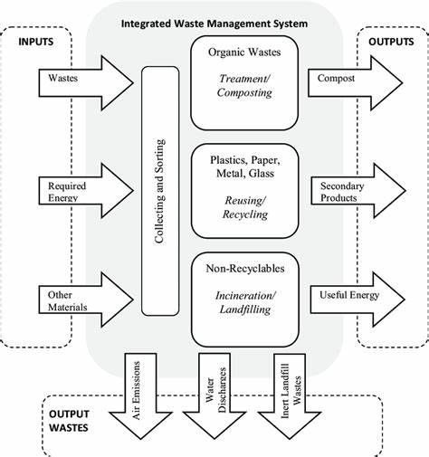

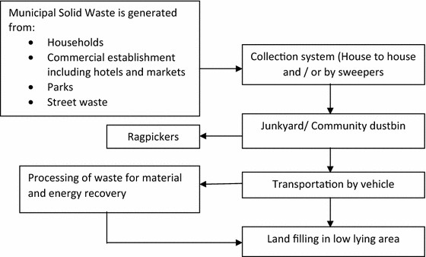

#### Fg 1.1 solid waste collection to disposal.

**Class diagrams**

These are the types of representations used to display hierarchical relationships. A class diagram can also be used to stand for several types of relationships, such as whole or part using composite connectors and aggregation connectors, interaction using dependence arrows, or associate using connecting lines. The waste management system's philosophy is the foundation for the class diagram that follows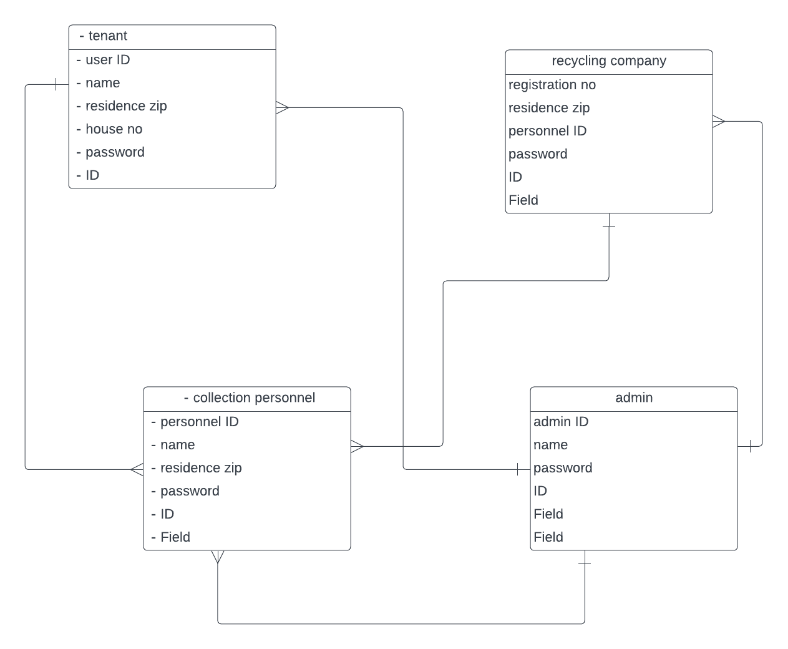

#### Fg1.3class diagram

**Use case diagram**

The use case diagram describes the relationship of various system users.

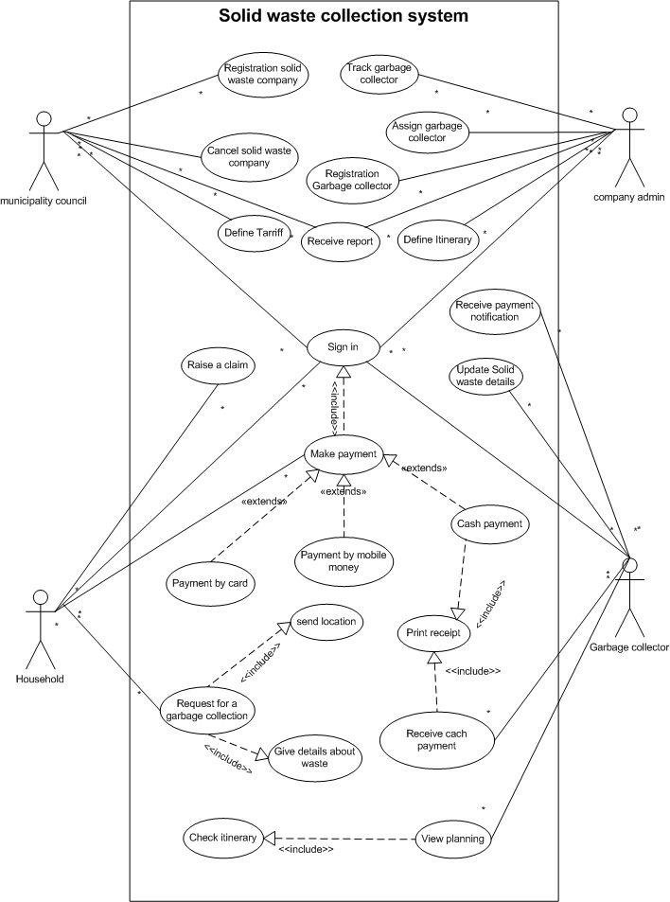

#### Fg 1.4 solid waste collection system use case diagram

**Activity diagrams.**

Control of one activity over another is shown in an activity diagram. The dynamic elements of the system are modeled using the activity diagrams. Most of the time, this entails modeling the computational process's sequential steps. The activities associated with using the waste management system by a member are depicted in the activity diagram below.

User home page

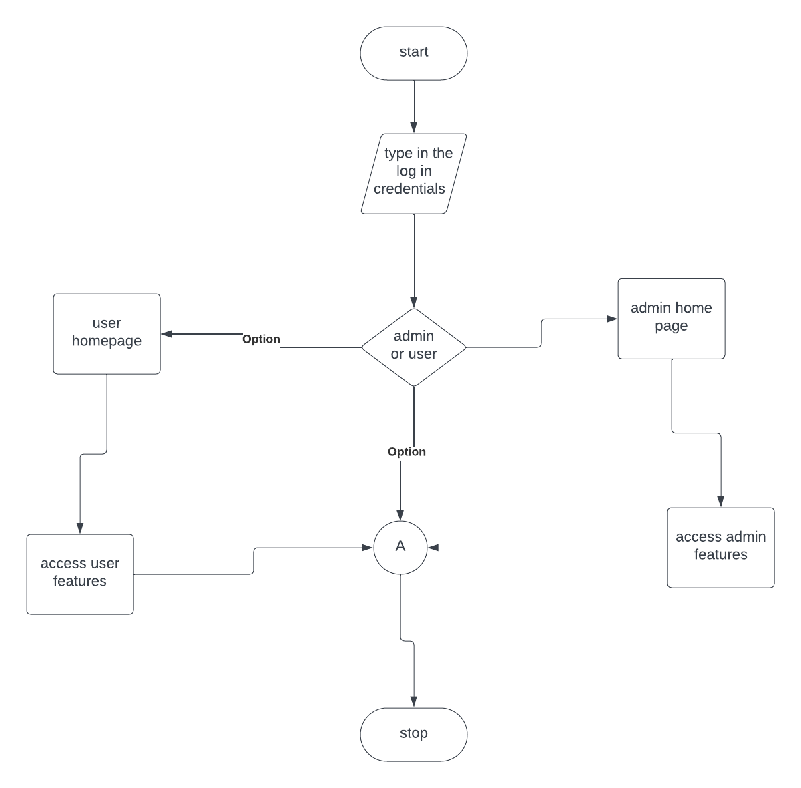

#### Fg 1.5 user home page

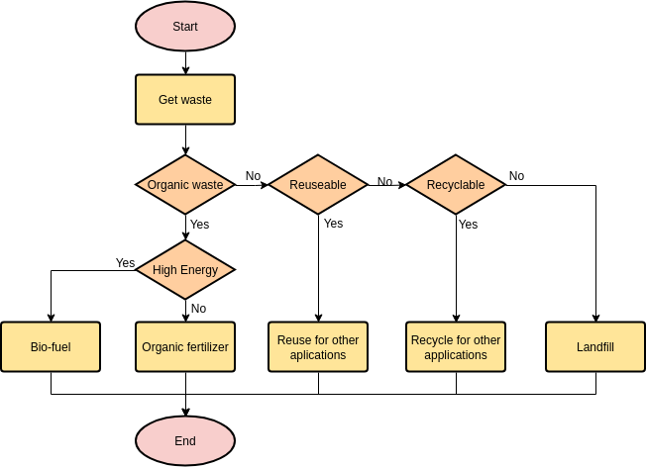

#### Fg 1.6 solid waste management

### **Program design**

**database design**

The normalization of the tables in the program is shown below.

|  |  |  |  |
| --- | --- | --- | --- |
| UNF | 1NF | 2NF | 3NF |
| Residence zip | User ID | User ID | User ID |
| User ID | First name | First name | First name |
| name | Second name | Second name | Second name |
| House no | Residence zip | House no | House no |
| Registration no | House no |  |  |
| Company name |  | Personnel ID | Personnel ID |
| Collection personnel | Personnel ID | Name | Name |
| First name | name | Collection company | Collection company |
| Second name | Collection company | Registration no |  |
| Personnel ID | Registration no |  | Company ID |
| Admin ID |  | Company ID | Company ID |
|  | Company ID | Company name | Admin ID |
|  | Company name | Residence zip |  |
|  | Residential zip |  |  |
|  |  | Admin ID |  |
|  | admin | admin |  |
|  | Admin ID |  |  |

**Database description**

**Tenants table**

|  |  |  |  |
| --- | --- | --- | --- |
| field | Data type | size | description |
| Tenant ID | int | 6 | Primary key |
| First name | Varchar | 20 |  |
| Second name | varchar | 20 |  |
| Residence zip char | char | 8 |  |
| Phone no | varchar | 20 |  |

**Collection personnel table**

|  |  |  |  |
| --- | --- | --- | --- |
| Field | Data type | size | description |
| Personnel ID | int | 6 | Primary key |
| First name | varchar | 20 |  |
| Second name | varchar | 20 |  |
| Phone no | Varchar | 20 |  |
| Collection company | varchar | 20 |  |

**Recycling company**

|  |  |  |  |
| --- | --- | --- | --- |
| Field | Data type | Size | description |
| Company ID | int | 6 | Primary key |
| Company name | varchar | 20 |  |

**Admin**

|  |  |  |  |
| --- | --- | --- | --- |
| Field | Data type | size | description |
| Admin ID | int | 6 | Primary key |
| First name | varchar | 20 |  |
| Second name | varchar | 20 |  |
| Phone no | varchar | 20 |  |

**User interface design**

**Internal machine interface**

The software will be installed on a computer and will use the server client approach with a database to store data. When a user updates a record, the system automatically updates on the database.

**External system interface**

Peripheral devices such as keyboards, mouse and other accessories are connected to the computer.

**Human interface**

Currently in the waste management system, only the administrative can make data changes. Normal users are prohibited from accessing the admin end and are only allowed to access certain features if they login with the right credentials.

**User interface design**

This concept depicts how the user will be able to communicate with the system for it to perform required tasks.

**Description of the user interface**

Form- will be used to capture information about the different entities of the database.

Buttons- will be used to start processing of the data and for navigation between different areas of the system.

Icons- these are images which stand for a certain function.

Error messages- these will be used to show when errors are made in the system.

**Components available**

The components available will use the CRUD approach which entails; create,read,update and delete as well as other key components.

Search- will be used to find a record in the system.

Update-will be used to make changes to an edited record in the database.

Save-used to save edited or entered data.

Delete-used to remove a record from the database.

Next-when clicked, allows movement to the next record.

**Software context**

The system will include several modules, a relationship to connect all the tables for relationship to work so that they can relate and share the data to carry out all the task the system is expected to do.

### **Chapter 6**

#### **Implementation and test plan**

**introduction**

Software testing is the procedure of examining software to ensure that it complies with requirements and assessing functionality to find anomalies and faults. The system is implemented once it satisfies all requirements.

**User manual**

**Overview**

It is obvious that waste management is a problem. The environment will always produce garbage after using products, as is the case. Without adequate waste management, both the environment and the local population, who will not be exempt from any negative consequences that may result, are more at danger of pollution.

After considering waste management, this project develops a solid strategy that intends to manage trash from the lowest level, where renters live in their residential areas, by applying a methodical solution to the current issue met.

Renters will be able to quickly obtain dependable rubbish collection services from their apartments or flats from waste collection professionals who will also be able to contact recycling businesses thanks to the implementation of this initiative. There is a guarantee that the environment will be kept clean and pollution-free thanks to this cycle.

**Installation**

Inexperienced users will find the system simple to install and use. For proper functionality, it will be installed and set up online, but testing will be carried out locally using a local server. The machine that will be running the system must have the following for the installation to be successful.

* MySQL for the database
* Apache HTTP (Hypertext Transfer Protocol) server.

**User role and definitions**

The following are some of the several roles that can connect to and access the waste management system.

* The administrator oversees adding, changing, and removing data as well as managing users.
* Depending on their roles, users will be able to communicate with the system and request services.

**Waste management system briefly**

The key feature of waste management are as follows

**Login and register section**-this will help new users and current users access the system, for new users they will use their credentials for authentication and accessing features. For those who do not register they will have to do the same to continue to login

**Profile selection**- as a user for can access your account information and edit information such as passwords.

**Features selection**-this allows the user to access a myriad of services which is the primary reason for using the system.

**The test plans**

A test plan describes software testing scope and activities. The test plan typically has a detailed understanding of what holds detailed understanding of what the eventual workflow will be.

Software to be tested-the software to be tested is the waste management system.

Testing strategy-the system testing was done in the following phases

**Unit testing**

This is the procedure for evaluating every system module independently. Each module is tested separately to confirm and validate the findings. That is what the coder does.

For instance, the register link needs ideally lead to the registration form itself, rather than inadvertently rerouting to an incorrect page.

**Validation test**

Validation testing entails deciding if the application responds to user input as intended. Comprehensive tests will also be performed on the software components to guarantee the best performance. A few of the components that will be examined are shown in the table below.

|  |  |  |
| --- | --- | --- |
| Activity | Expected results | conclusion |
| add | Insert a new record in the database | ok |
| add | Remove required field | ok |
| Update | Should make changes to the existing record | ok |
| save | Should save existing  and new entries to the database | ok |

**Test schedule**

|  |  |  |  |  |  |
| --- | --- | --- | --- | --- | --- |
| *activity* | // | timeline |  |  |  |
|  |  |  |  |  |  |
| *Design Test Plans* |  |  |  |  |  |
| *Build System test/procedures* |  |  |  |  |  |
| *Create test environment* |  |  |  |  |  |
| *Execute predefined tests* |  |  |  |  |  |
| *Generate test report* |  |  |  |  |  |

**Testing resource**

Among the crucial resources for system testing are:

1. A local server for non-online evaluation

2. A laptop or desktop PC with sufficient storage.

3. HTTP Apache

4. MySQL

5.xampp

**Conclusion**

One of the most important aspects of developing a system is testing it to ensure it satisfies user requirements and can be used. To find faults and anomalies that might not have been found during the development stage, system testing is also needed.

**Sample code**

The waste management system code is contained in this section; in this case, I will use the sign-in and sign-up pages, respectively.

Login page

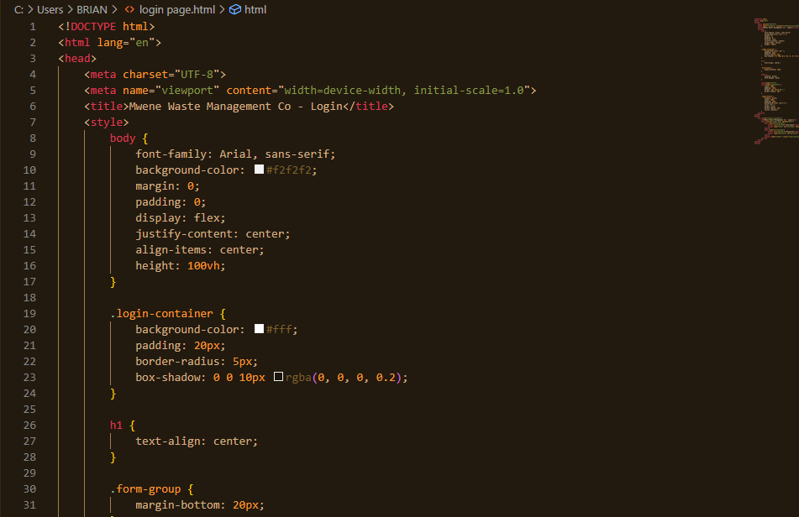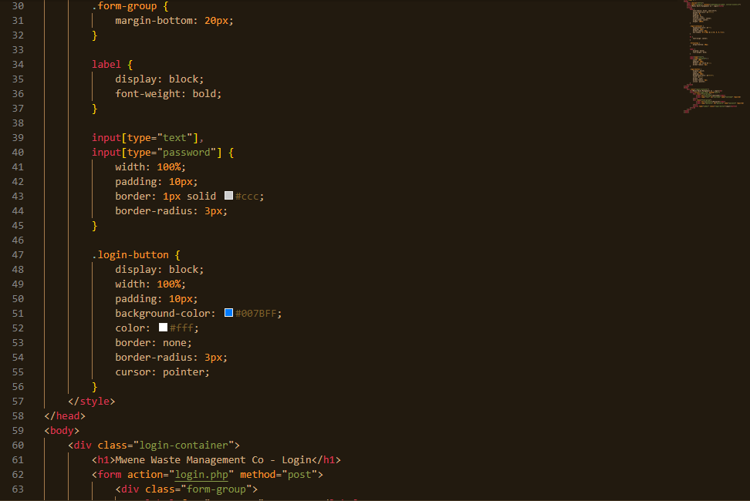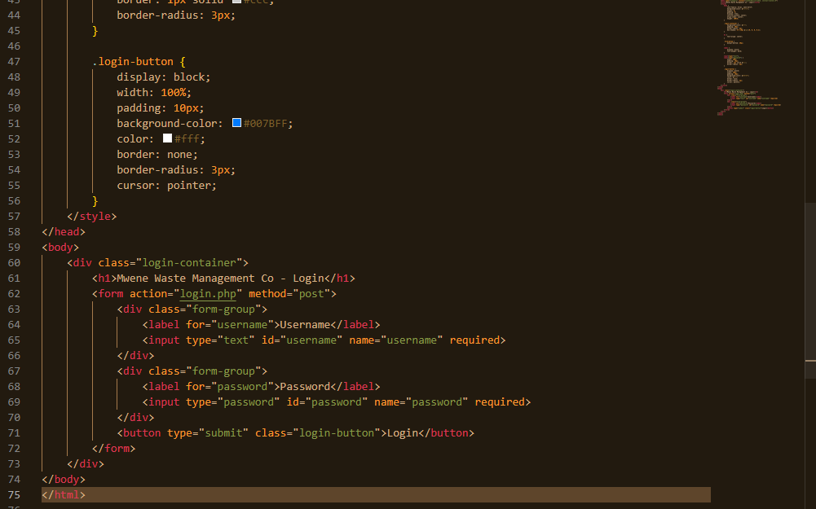

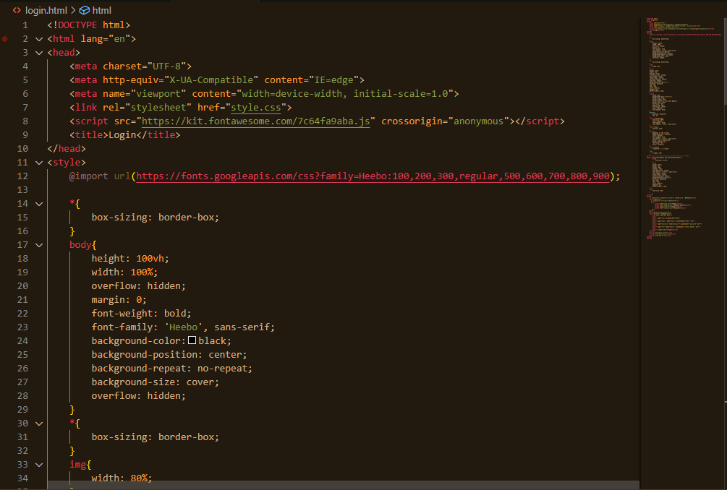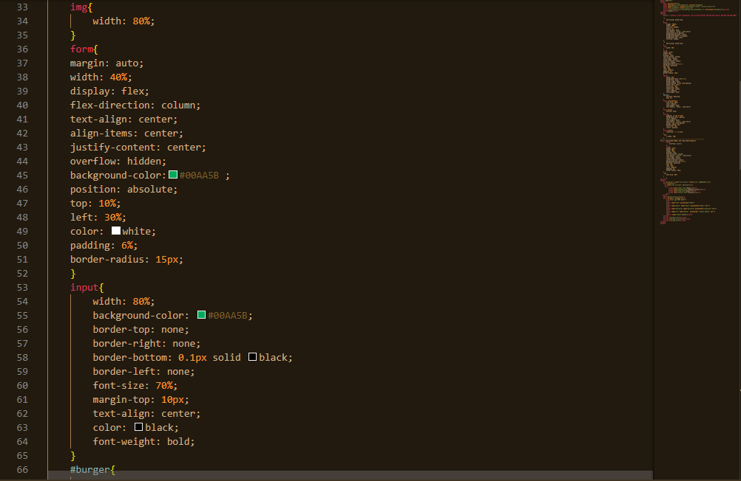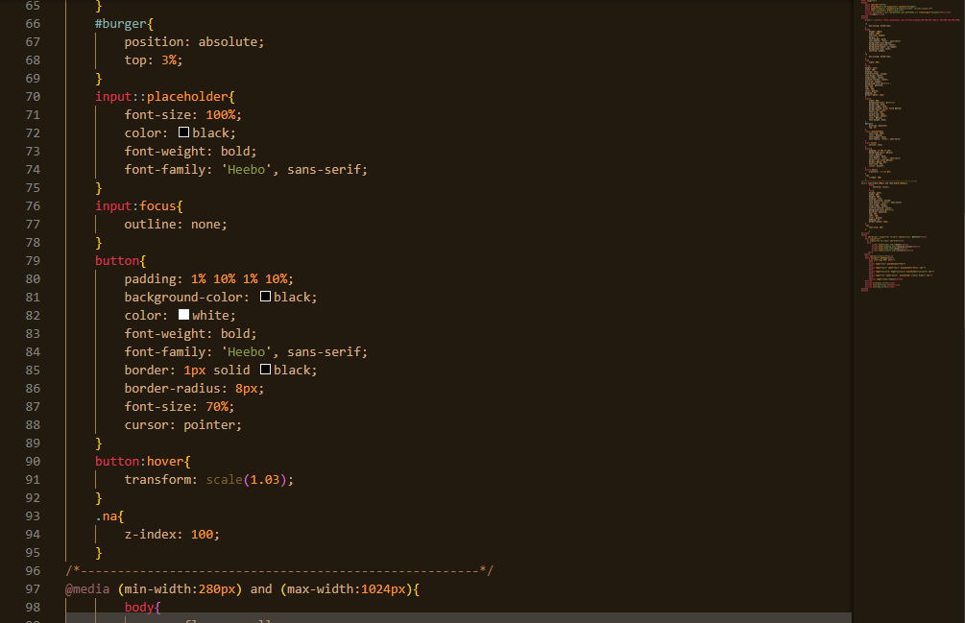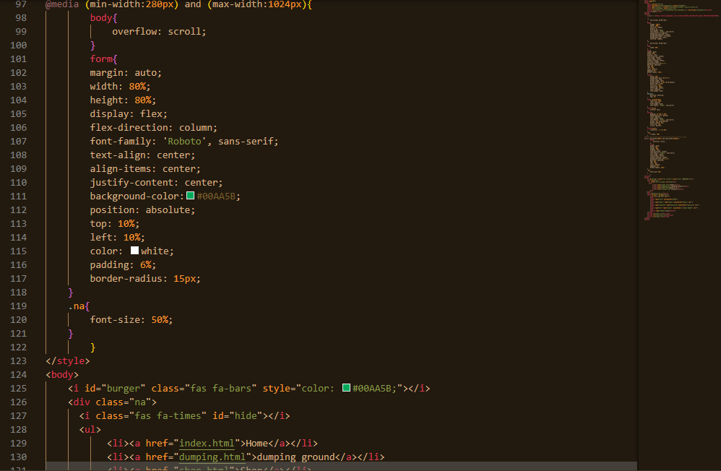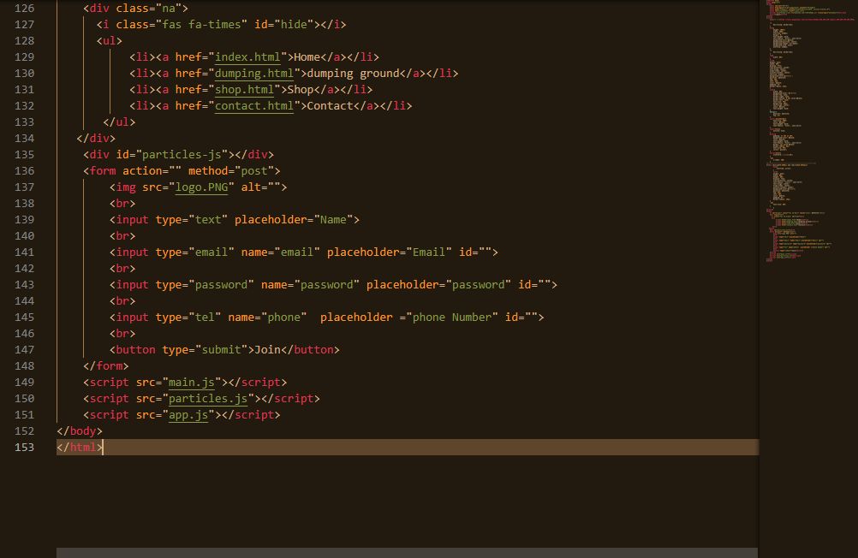

Screenshots

This is a screenshot for the waste management system website for clients to create and log into their accounts.

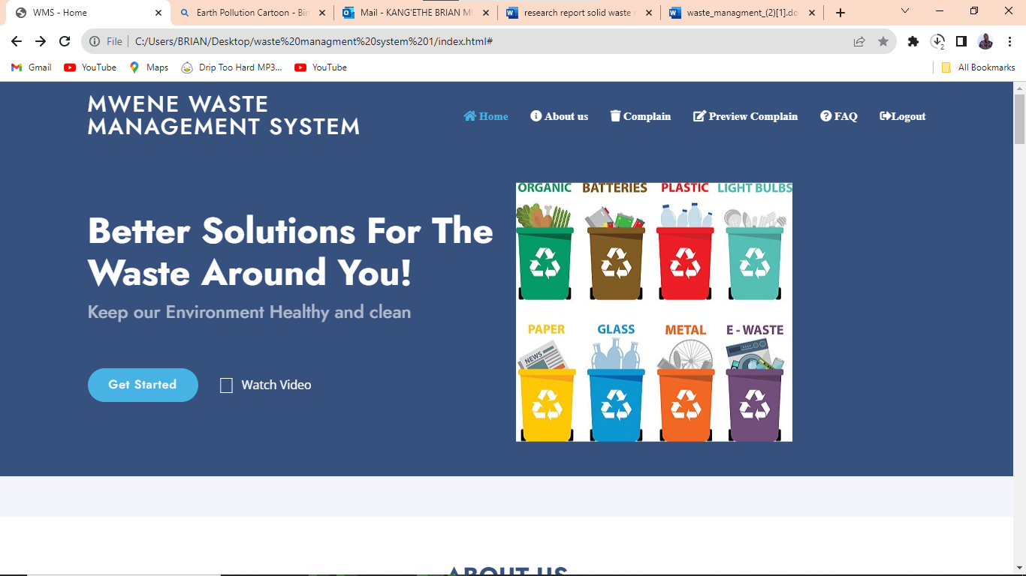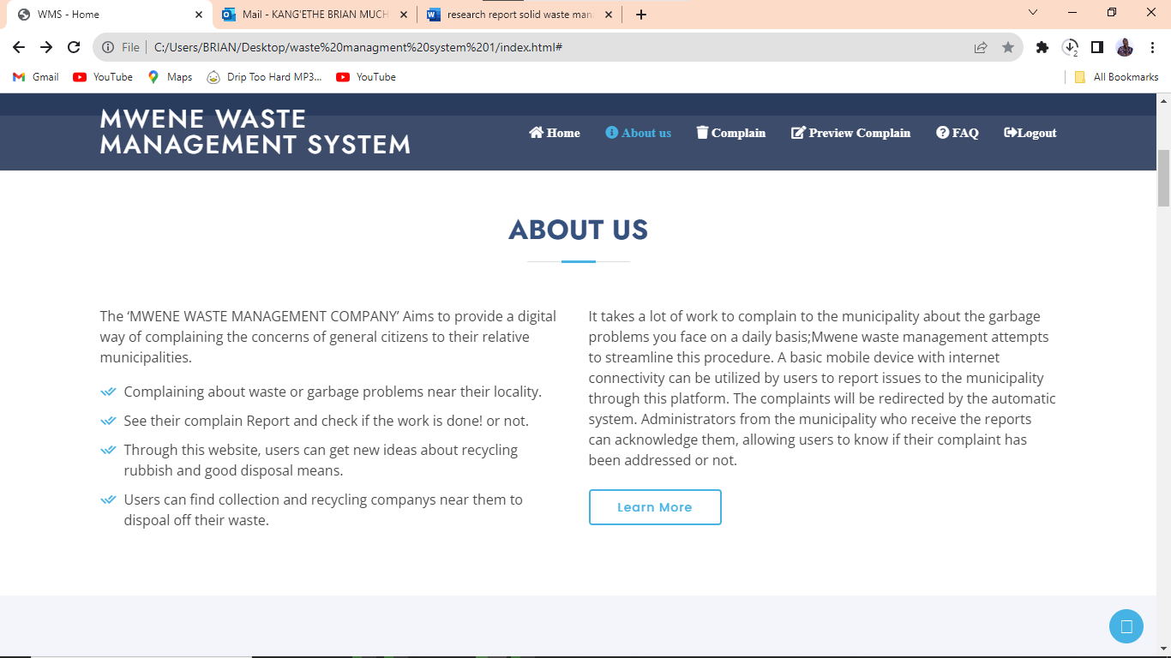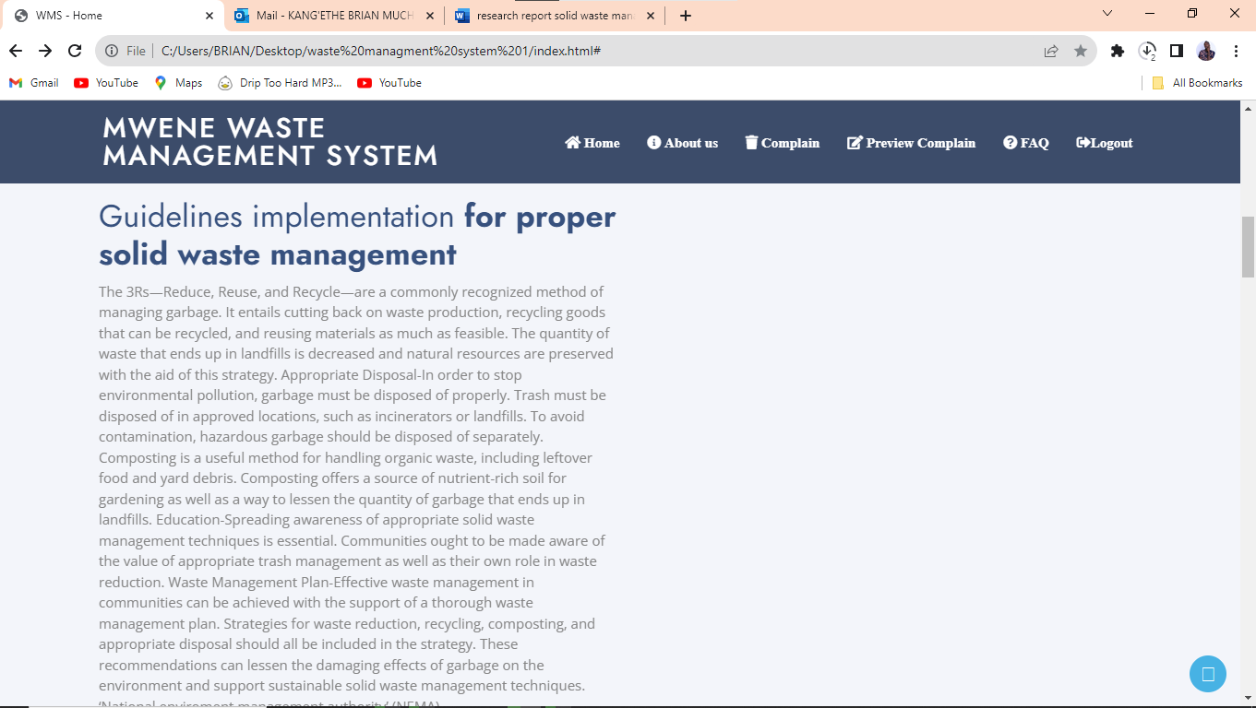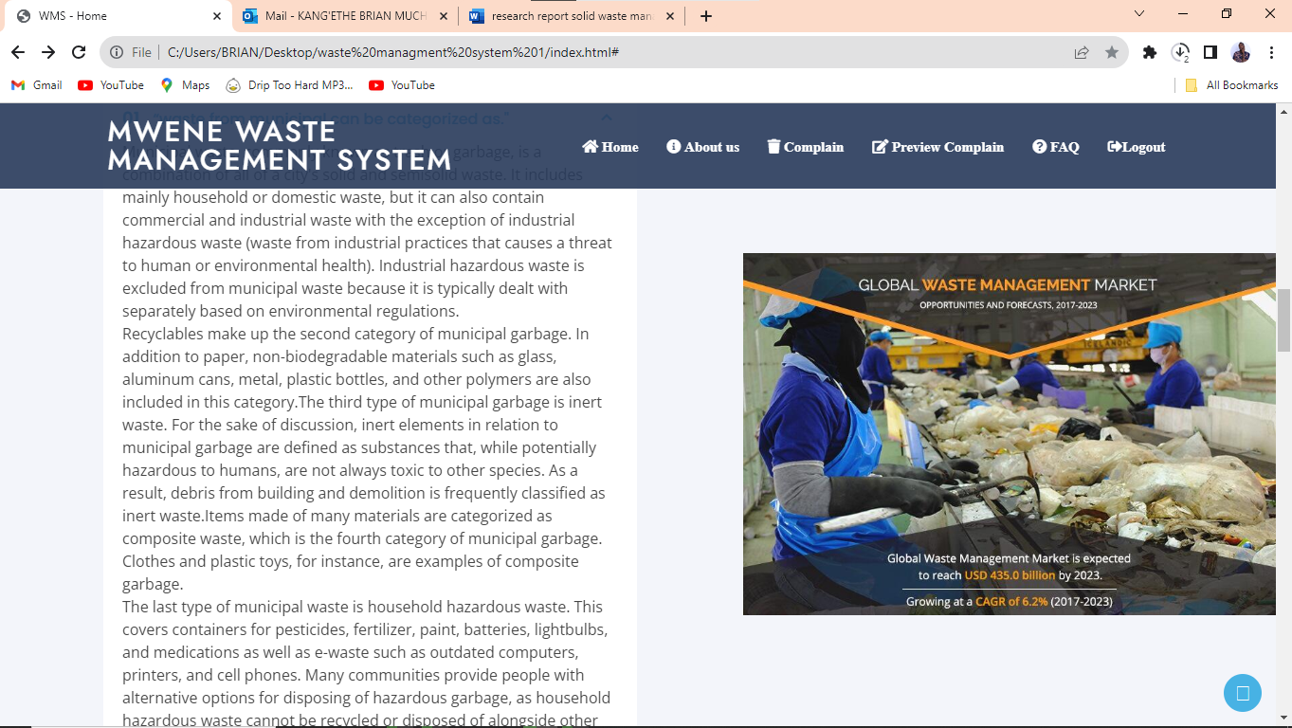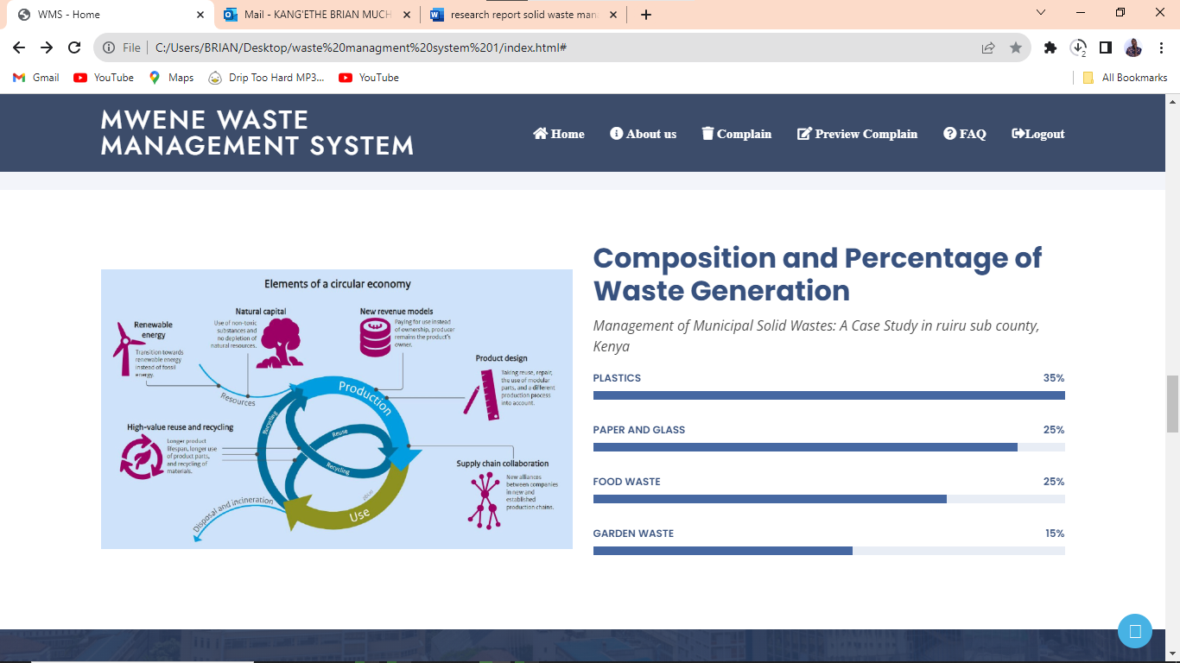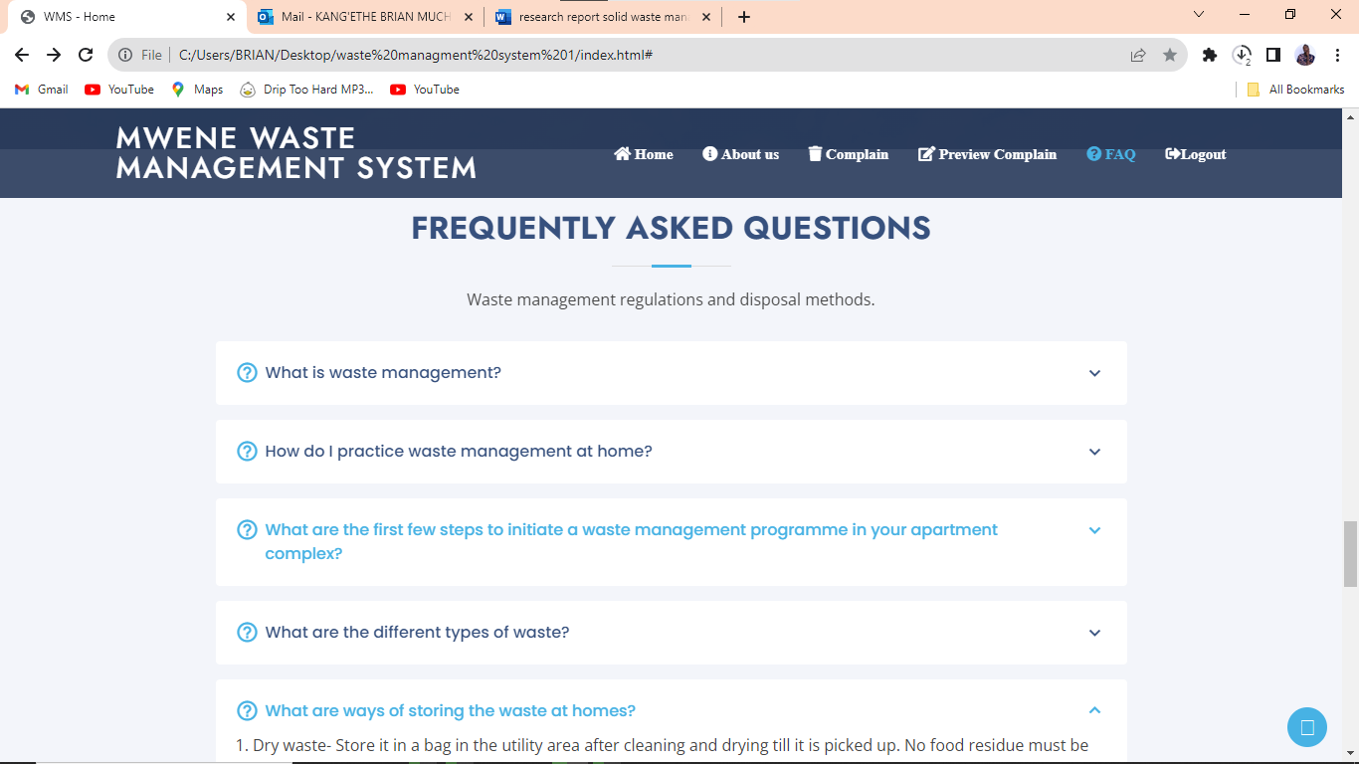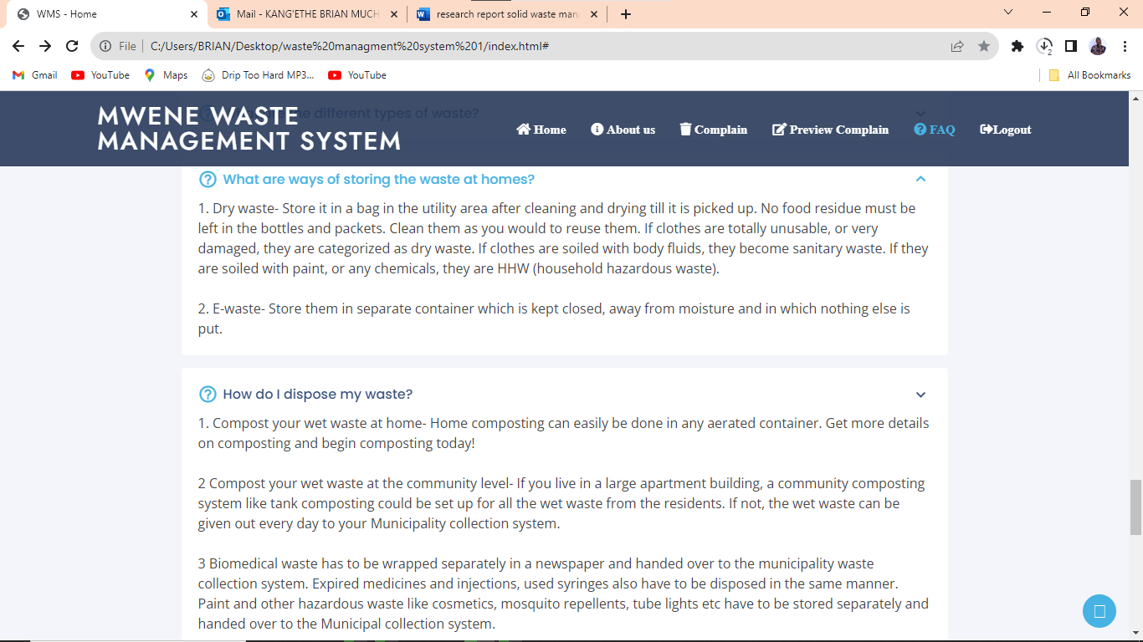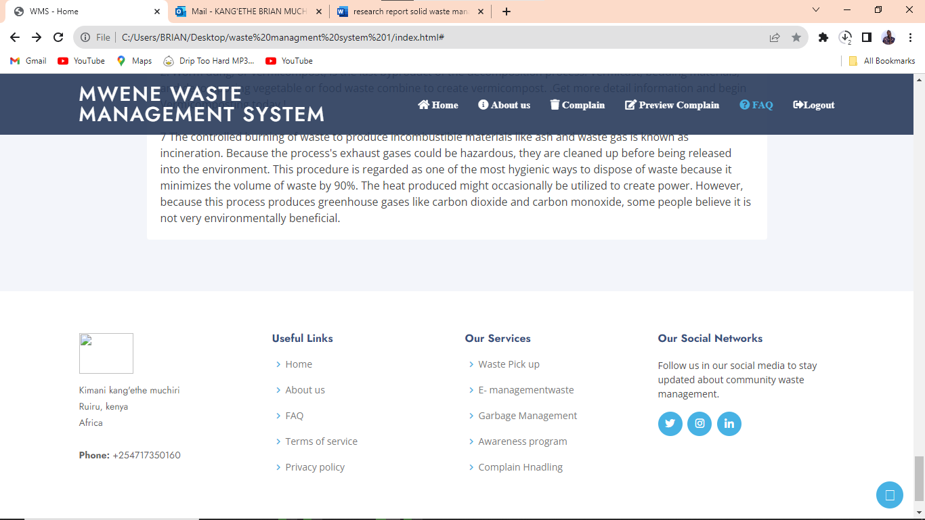

### **Chapter 7**

### **Conclusion, recommendation, and references**

**Conclusion**

I thus conclude that this project is effective and right for use across the nation to aid in waste management to support a clean environment. There is no doubt that it can also go through more modification, such as the use of GPS units and aerial photography to demarcate waste collection areas to increase its performance and make it more appealing, and most importantly, to make waste management simple for tenants.

**Budget**

|  |  |
| --- | --- |
| Expenditure | Estimated cost |
| Laptop | 70000 |
| Printing cost | 3500 |
| External hard drive | 4000 |
| Wi-Fi charges | 10000 |
| Research cost | 50000 |
| Software charges | 40000 |
| Travel cost | 15000 |
| total | 192500 |

**Project schedule**

|  |  |  |  |  |
| --- | --- | --- | --- | --- |
|  | Jan 2023 | March 2023 | June 2023 | Sep 2023 |
| *Activity months* | 1-2 | 3-5 | 6-9 | 10-12 |
| *Idea creating* |  |  |  |  |
| *Proposal document* |  |  |  |  |
| *Proposal presentation* |  |  |  |  |
| *System requirement and specification* |  |  |  |  |
| *System design and specification* |  |  |  |  |
| *System implementation and testing* |  |  |  |  |

**Project risk and mitigation**

|  |  |  |
| --- | --- | --- |
| Risk | effect | mitigation |
| Project data loss | All the work done will not be available | Having a backup on a cloud or external hard drive |
| Programming language and software update problems | Frequent runtime problem and troubleshooting | Updating the software version |
| Lack of finances | Delay on the project | Using what is available at hand |

**Recommendation**

The World Bank Group (2021) has supplied information that supports the recommendation that municipal solid waste be handled using a waste hierarchy approach, which prioritizes initiatives to reduce consumption over those centered-on garbage collection, recovery, and disposal1. This strategy supports the circular economy theory, which encourages the recycling of end-of-life goods back into the economy and the minimization of waste.

But it is crucial to remember that many national initiatives still do not fully incorporate these ideas1. It is essential for banks like the World Bank Group to address more MSWM (Municipal Solid Waste Management) determinants in more activities to create an integrated strategy to municipal solid waste management (MSWM).

The Environmental Protection Department (EPD) in Hong Kong has set up medium-term goals in addition to this World Bank Group (2021) guideline. These include gradually lowering the per capita MSW disposal rate by 40–45% through the implementation of MSW Charging and increasing the recovery rate to 55%.

Waste segregation bins: Distinct types of waste segregation bins are included in the system to separate food waste from other types of waste.

Composting area: This area holds the composting bins, which are used in the decomposition process. A cover is also supplied to protect the compost from rain and direct sunlight.

Sensors and software in the monitoring system track the amount and type of waste generated, the composting process, and the quality of the resulting compost.

**Implementation plan**

Site evaluation: A site evaluation will be performed to decide the best location for the waste segregation and composting areas.

Installation: The waste segregation and composting bins will be installed, as well as the monitoring system.

Employees will receive training in waste separation and composting techniques and the monitoring system.

Testing: The system will be tested to ensure that it is operationally sound and to find any potential problems.

**Financial analysis**

Capital costs include the purchase of waste segregation bins, composting bins, a monitoring system, and installation.

Operating expenses include the costs of labor, maintenance, and electricity.

Benefits include lower food waste and associated costs, increased efficiency and productivity, and the creation of nutrient-rich compost.

According to the financial analysis, the project is financially practical and can save the food processing plant a lot of money.

**Technical feasibility**

Technically, the proposed waste collection system is possible. The system is based on modern waste collection infrastructure and smart waste collection technology, both of which have been implemented successfully in other cities. The centralization of waste collection points will improve waste management by lowering collection costs and increasing waste collection efficiency.

**Economic feasibility**

The suggested waste collection system is economically helpful. The system will require a large investment in innovative waste collection infrastructure and smart waste collection technologies. However, the new system's long-term advantages, such as reduced collection costs, enhanced effectiveness, and improved waste management, will outweigh the upfront expenses.

**Social feasibility**

The waste collection system proposed is socially possible. The system will improve the city's quality of life by reducing waste on the streets and improving public health. The public education program will also increase residents' awareness of the importance of proper waste disposal and encourage them to take part in waste reduction and recycling efforts.

**Kenya laws and policies on waste management issues**

The Environmental Management and Coordination Act of 1999 (EMCA): This act governs the management of Kenya's environment and natural resources. It shows the framework for waste management, including the formation of the National Environment Management Authority (NEMA), which oversees regulating and coordinating all environmental activities.

The 2006 Waste Management Regulations: These regulations govern waste management in Kenya, including waste classification and the roles of waste generators and waste managers. The regulations also establish waste disposal standards, such as the use of landfills and incineration.

The 2016 National Solid Waste Management Strategy (NSWMS): This strategy sets up a framework for solid waste management in Kenya. It sets up the waste management policy and institutional framework, waste reduction, recycling, and disposal strategies.

Kenya's 2010 Constitution: Kenya's constitution calls for the protection and conservation of the environment and natural resources. It also recognizes everyone is right to a clean and healthy environment, as well as the state's and individuals' responsibility to protect and conserve the environment.

Overall, Kenya's waste management laws and policies supply a comprehensive framework. However, there are still obstacles to enforcing these laws and policies, such as insufficient funding and infrastructure, as well as low public awareness and participation.

**Conclusion**

Solid waste generation and management is a growing issue that must be addressed at once. While there are several potential solutions to this problem, it is critical to develop a comprehensive strategy that addresses both solid waste generation and management. This will need collaboration among governments, businesses, and the public to develop effective policies and strategies to reduce waste generation and improve waste management systems.

**References**

*The potential of sustainable biogas production from animal waste*. (2021, August 20). The Potential of Sustainable Biogas Production from Animal Waste - ScienceDirect. <https://doi.org/10.1016/B978-0-12-823139-5.00003-4>

*Enhancing food security and environmental sustainability: A critical review of food loss and waste management*. (2021, March 24). Enhancing Food Security and Environmental Sustainability: A Critical Review of Food Loss and Waste Management - ScienceDirect. <https://doi.org/10.1016/j.resenv.2021.100023>

*ICE Virtual Library*. (n.d.). ICE Virtual Library. <https://www.icevirtuallibrary.com/doi/full/10.1680/warm.12.00005>

Banerjee, S. (n.d.). *waste management 2013.pdf*. (PDF) Waste Managment 2013.pdf | Soumyajit Banerjee - Academia.edu. <https://www.academia.edu/33506980/waste_managment_2013_pdf>

*ICE Virtual Library*. (n.d.). ICE Virtual Library. <https://www.icevirtuallibrary.com/doi/full/10.1680/warm.12.00005>

Shafiq, M. (n.d.). *Municipal Waste*. (PPT) Municipal Waste | Mohd Shafiq - Academia.edu. <https://www.academia.edu/3660853/Municipal_Waste>

Beede, D. N., & Bloom, D. E. (n.d.). *The economics of municipal solid waste*. (PDF) the Economics of Municipal Solid Waste | David Beede - Academia.edu. <https://www.academia.edu/1828903/The_economics_of_municipal_solid_waste>

*The potential of sustainable biogas production from animal waste*. (2021, August 20). The Potential of Sustainable Biogas Production from Animal Waste - ScienceDirect. <https://doi.org/10.1016/B978-0-12-823139-5.00003-4>

*Enhancing food security and environmental sustainability: A critical review of food loss and waste management*. (2021, March 24). Enhancing Food Security and Environmental Sustainability: A Critical Review of Food Loss and Waste Management - ScienceDirect. <https://doi.org/10.1016/j.resenv.2021.100023>

*ICE Virtual Library*. (n.d.). ICE Virtual Library. <https://www.icevirtuallibrary.com/doi/full/10.1680/warm.12.00005>

Banerjee, S. (n.d.). *waste management 2013.pdf*. (PDF) Waste Managment 2013.pdf | Soumyajit Banerjee - Academia.edu. <https://www.academia.edu/33506980/waste_managment_2013_pdf>

Shafiq, M. (n.d.). *Municipal Waste*. (PPT) Municipal Waste | Mohd Shafiq - Academia.edu. <https://www.academia.edu/3660853/Municipal_Waste>

Beede, D. N., & Bloom, D. E. (n.d.). *The economics of municipal solid waste*. (PDF) the Economics of Municipal Solid Waste | David Beede - Academia.edu. <https://www.academia.edu/1828903/The_economics_of_municipal_solid_waste>

Magar, S. B. (n.d.). *ANAEROBIC DIGESTION OF BIODEGRADABLE ORGANICS IN MUNICIPAL SOLID WASTES Submitted in partial fulfillment of the requirements for Master of Science Degree in Earth Resources Engineering*. (PDF) ANAEROBIC DIGESTION OF BIODEGRADABLE ORGANICS IN MUNICIPAL SOLID WASTES Submitted in Partial Fulfillment of the Requirements for Master of Science Degree in Earth Resources Engineering | Saroj Budha Magar - Academia.edu. <https://www.academia.edu/7679502/ANAEROBIC_DIGESTION_OF_BIODEGRADABLE_ORGANICS_IN_MUNICIPAL_SOLID_WASTES_Submitted_in_partial_fulfillment_of_the_requirements_for_Master_of_Science_Degree_in_Earth_Resources_Engineering>